**EXPERIMENT-1**

# CLASS-B POWER AMPLIFIER

# (COMPLEMENTARY SYMMETRY AMPLIFIER)

-----------------------------------------------------------------------------------------------------------------------------------------------------------------------------------------------------------------------------------------------------------------------------------------------------------------------------------------------

1. To design class-B Complementary symmetry power amplifier with the observation of crossover distortion for small signal input.
2. To calculate the theoretical and practical values of max efficiency.{( ηmax)class-B=78% **}**
3. **Aim:**
4. **Specification:** The maximum efficiency required is 78% which need to be improved from class-A Power ampler. Take Vcc=12V, Vss=-12V, use power transistors.
5. **Apparatus**

**Hardware:**

1. Silicon-NPN-transistor2N6517 Hardware-SL100
2. Silicon-PNP-transistor2N6520
3. Resistors RL=470Ohms
4. DRO
5. Signal generator
6. Bread board

**Software:**

1. Circuit Simulator: to verify the functionality of NPN and PNP Transistors
2. NI-Multisim-14.0-desktop app: to calculate circuit parameters
3. **Theory:**

**About Transistors:**

1. BC107- BC stands for Buried Channel
2. SL100 or CL100 –NPN (for Hardware)
3. CK100 or SK 100- PNP (for Hardware)

**About Power Amplifier:**

Class-B Operation: In Class-B operation, each active element (transistor) conducts for only one-half (180 degrees) of the input signal cycle. Class-B amplifiers are more efficient than Class-A amplifiers but can introduce distortion, particularly crossover distortion, where there is a gap between the positive and negative halves of the signal. Complementary symmetry involves using both NPN (Negative-Positive-Negative) and PNP (Positive-Negative-Positive) transistors in the amplifier circuit. The NPN and PNP transistors work together to handle both positive and negative halves of the input signal, providing a balanced and symmetric operation. Combining these principles results in a Complementary Symmetry Class-B Power Amplifier, where both the positive and negative halves of the signal are handled by NPN and PNP transistors working in complementary pairs. This configuration aims to improve efficiency by allowing each type of transistor to handle the portion of the signal where it operates more efficiently.

1. **Schematic:** complementary symmetry circuit with distortion in class-B Power amplifier

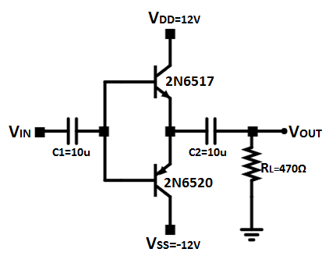

Figure 1. Zero bias complementary symmetry circuit

1. **Procedure:**
2. Connect the circuit as per the circuit diagram
3. Apply 2 v p-p with 1KHZ frequency using function generator
4. Observe the output in CRO.
5. Note the cross over distortion in output.(output Vp-p)
6. Remove the collector connection and put ammeter.
7. Note the IDC value from VCC and VSS
8. Using PDC and Pac formulas find the efficiency
9. **Model graphs:**

 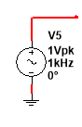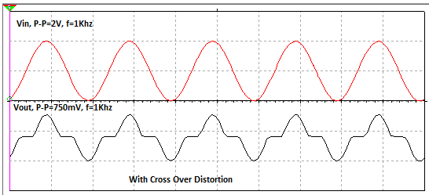

Figure 2. Input and output transient response of power amplifier, with crossover distortion

 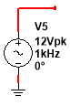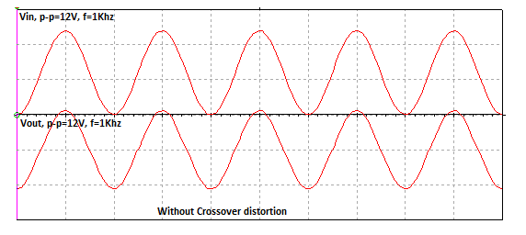

Figure 3. Input and output transient response of power amplifier, where crossover distortion is neglected due to large input

1. **Observations:**
2. The AC input is applied to two transistors. During positive half cycle, NPN transistor conducts and PNP transistor does not conduct. During negative half cycle, PNP transistor conducts and NPN transistor does not conduct.
3. To bring the transistor into active region from the cut off region, the transistor takes the cut in voltage from the input. Due to this, we get crossover distortion in class-B power amplifier which shown in figure 2.
4. To make crossover distortion dominant the input strength is increased to the peak strength of VDD so as to calculate maximum power dissipation as shown in the figure 3.
5. **Calculation of circuit Parameters**

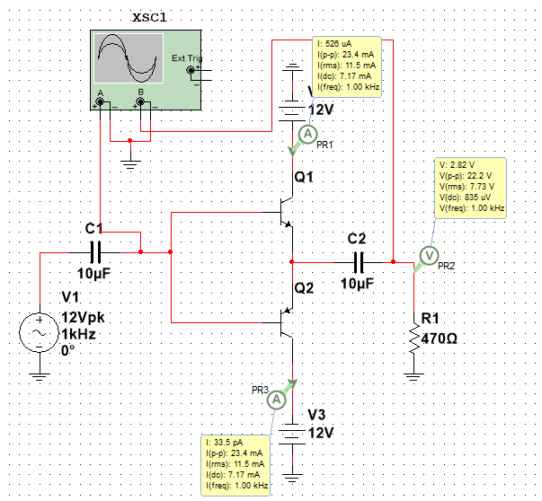

**PDC2=IDC2*VDD= -7.17mA*-12V**

**PDC1=IDC1*VDD=7.17mA*12V**

**IDC2=-7.17mA**

**IDC1=7.17mA**

**VRMS=7.73V**

Figure 4. Calculations of IDC from VCC and VSS branches to calculate DC input Power

-----------------------------------------------------------------------------------------------------------------------------

Practical calculation of efficiency= % ήMAX = == **73.8%**

-----------------------------------------------------------------------------------------------------------------------------

(Input DC power)DC1 = V­DD . =12 * IDC=12 * 7.17mA=86.04mW

(Input DC power)DC2 = -V­DD. =-12 * IDC=-12 * -7.17mA=86.04mW

**Total DC Input Power** = PDC1 + PDC2 =86.04mW +86.04mW = 172.08mW

**Output AC power:** AC power = Vrms *. Irms= $\frac{Vm}{\sqrt{2}}*\frac{Im}{\sqrt{2}}$ = $\frac{({V_{RMS})}^{2}}{RL}$ = $\frac{({7.73)}^{2}}{470}$ =127.13mW

-----------------------------------------------------------------------------------------------------------------------------

Theoretical calculation of efficiency = $\frac{Output AC power}{Input DC power}$

-----------------------------------------------------------------------------------------------------------------------------

% ήMAX = = = 78.5% (Where (Vm) max=Vin-Peak=VCC)

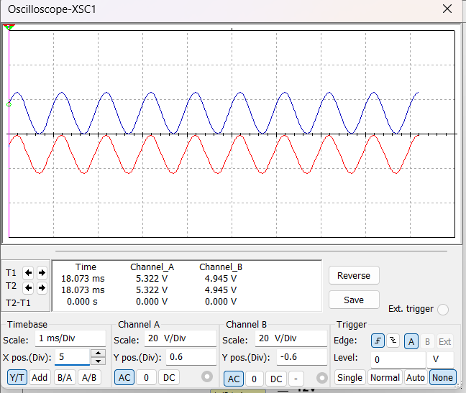

**Without Crossover Distortion**

**Vout**

**Vin**

Figure 5. Input and output transient response of power amplifier, where crossover distortion is neglected due to large input

1. **Power amplifier with low input signal[1Vpk]:**

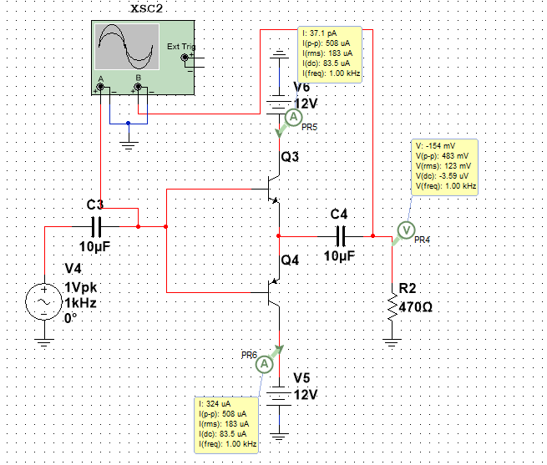 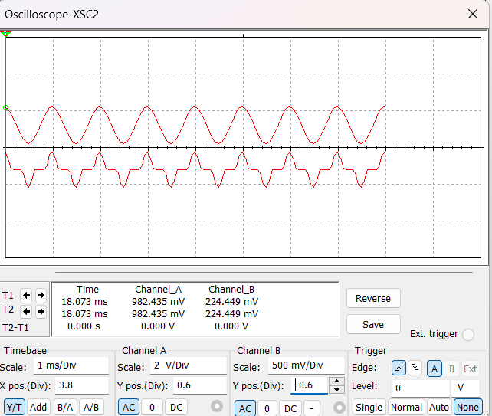

**With Crossover Distortion**

**Note:-If we give very low ac input signal, the transistor goes into the cut off region since transistor requires 0.7V to come out of the cut off region, so the signal gets distorted.**

1. **Beyond the content : Modified as Class-AB Power Amplifier for eliminating distortion:**

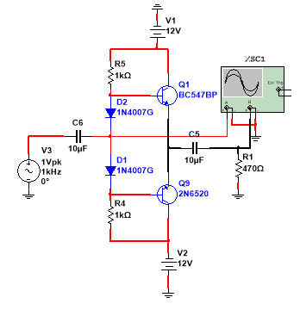 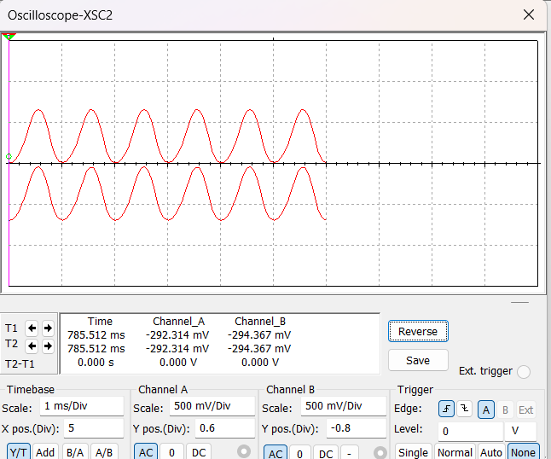

Vout

Vin

Figure 6. Class-AB power amplifier to eliminate the distortion for small signal input.

Scale:

1. **Output for RL=1MΩ:**

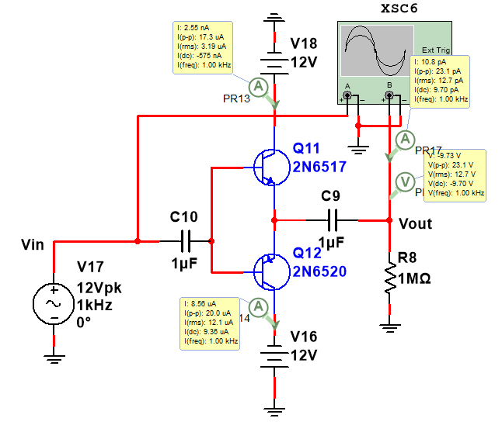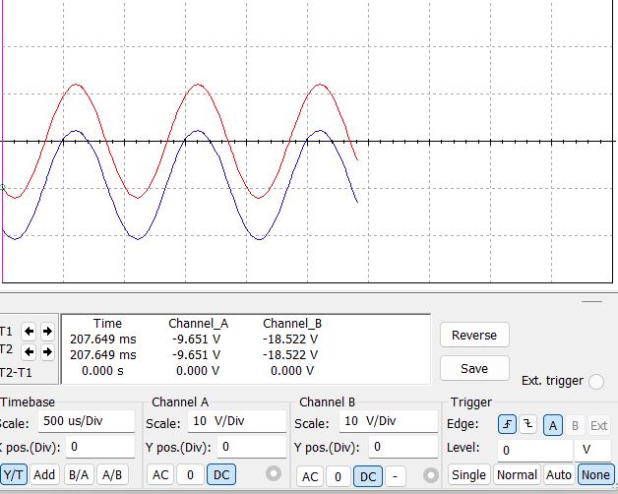

As RL increases the O/P Wave form is shifting downwards and I/P and O/P are in phase and vice-versa.

1. **Result:**

|  |  |
| --- | --- |
| Efficiency(𝝶) | |
| Theoretical | 78.5% |
| Practical | 73.8% |

Signature of the Faculty